Sallins
Draft Local Area Plan 2015-2021
Dréachtphlean Cheantair Áitiúil Na Solláin



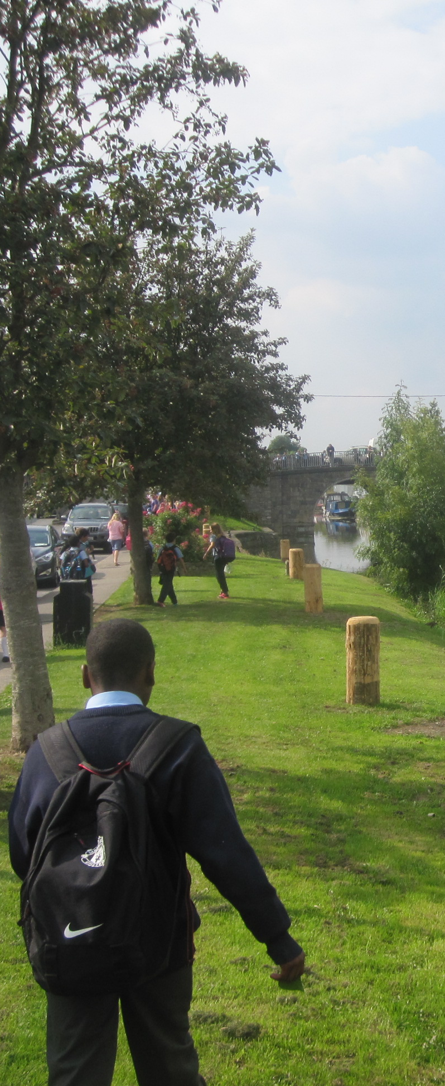
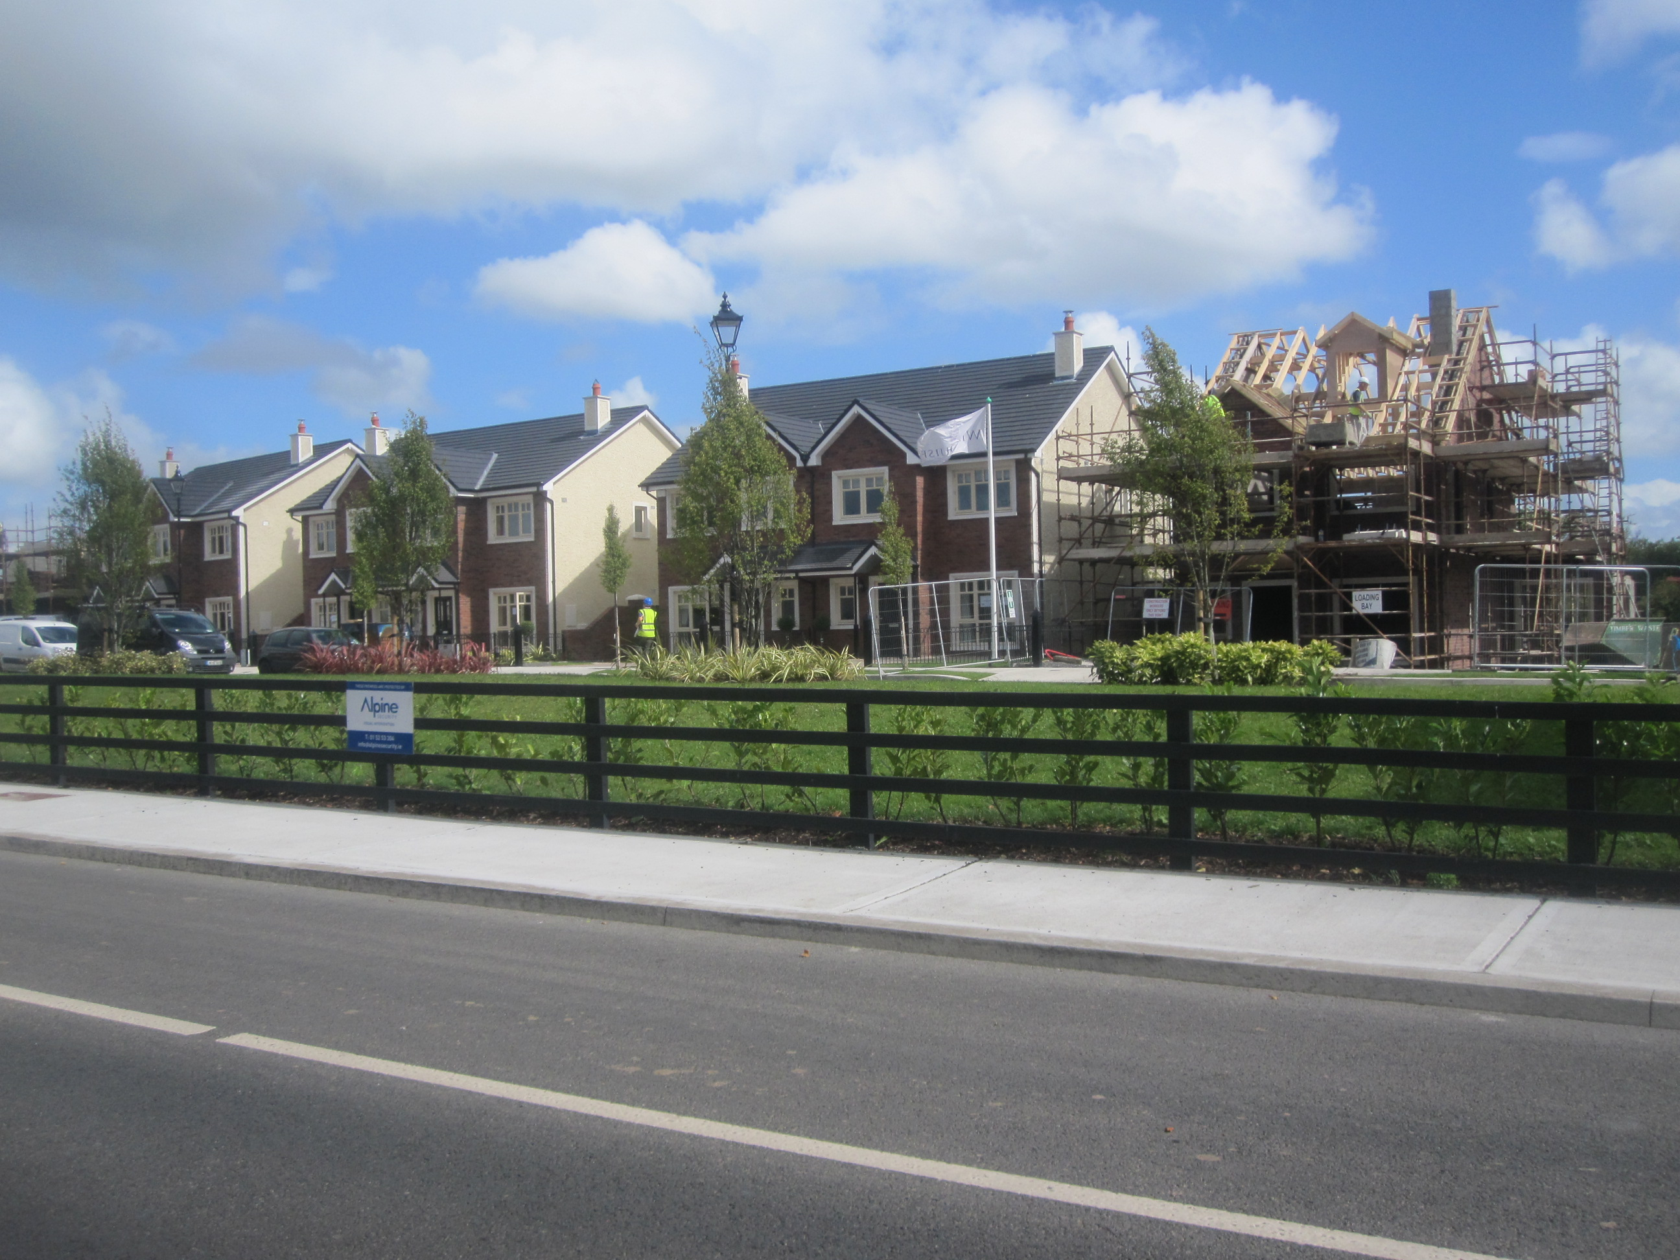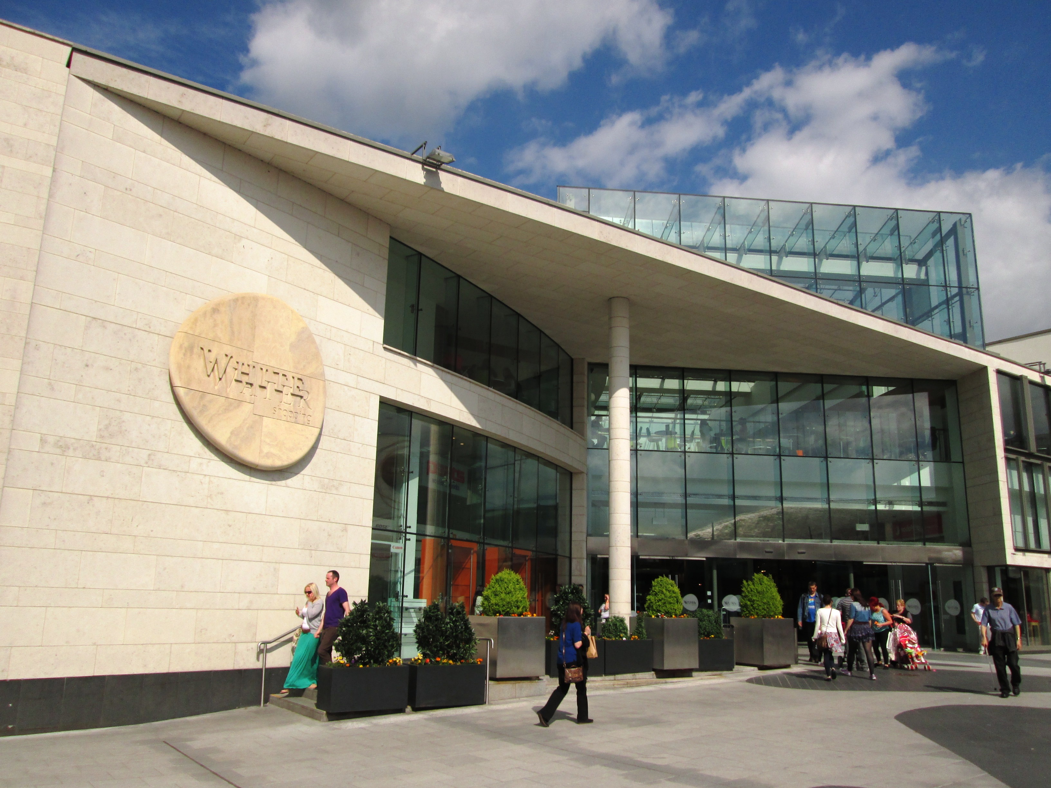
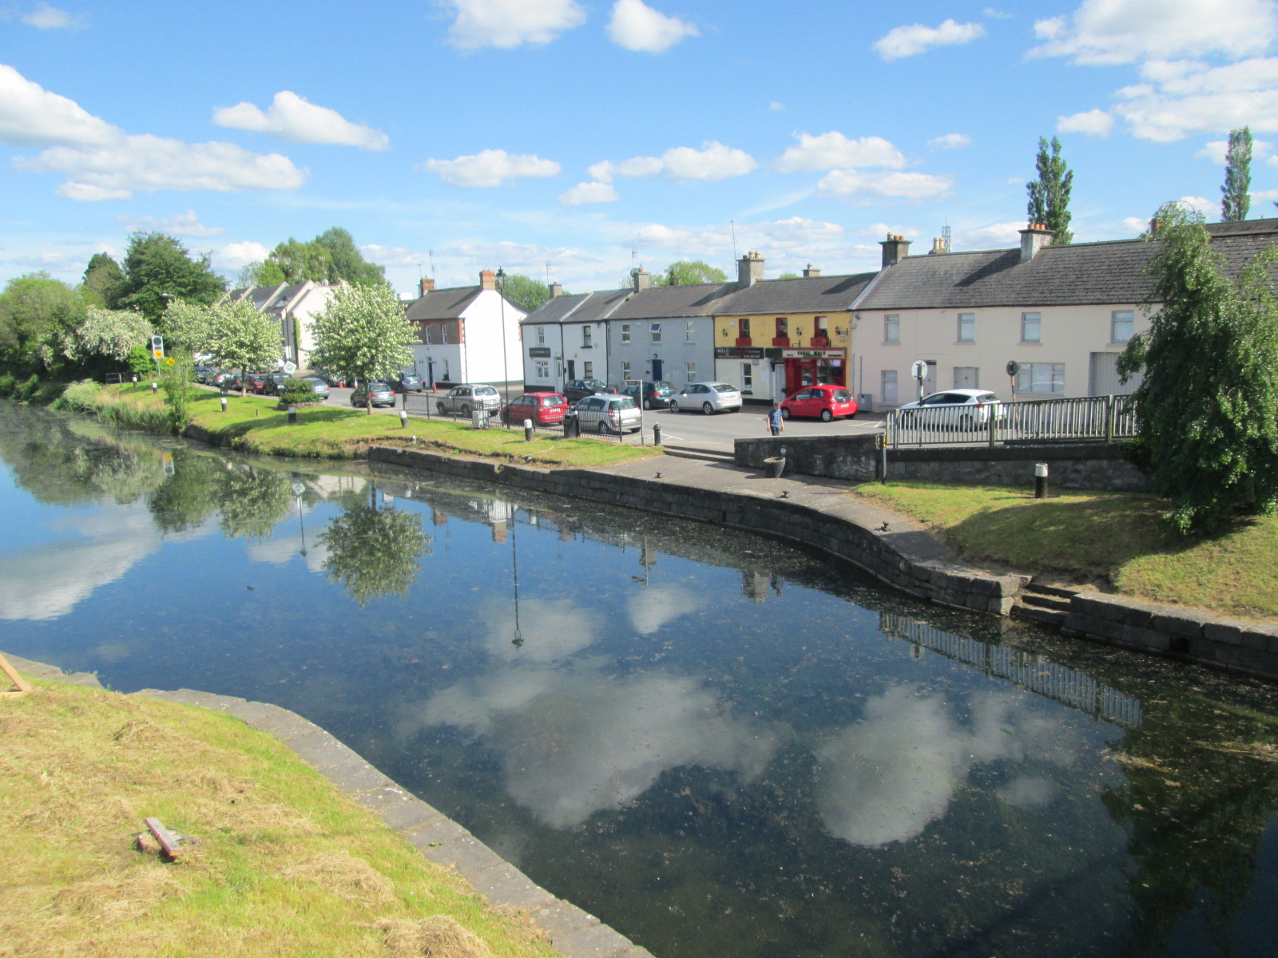

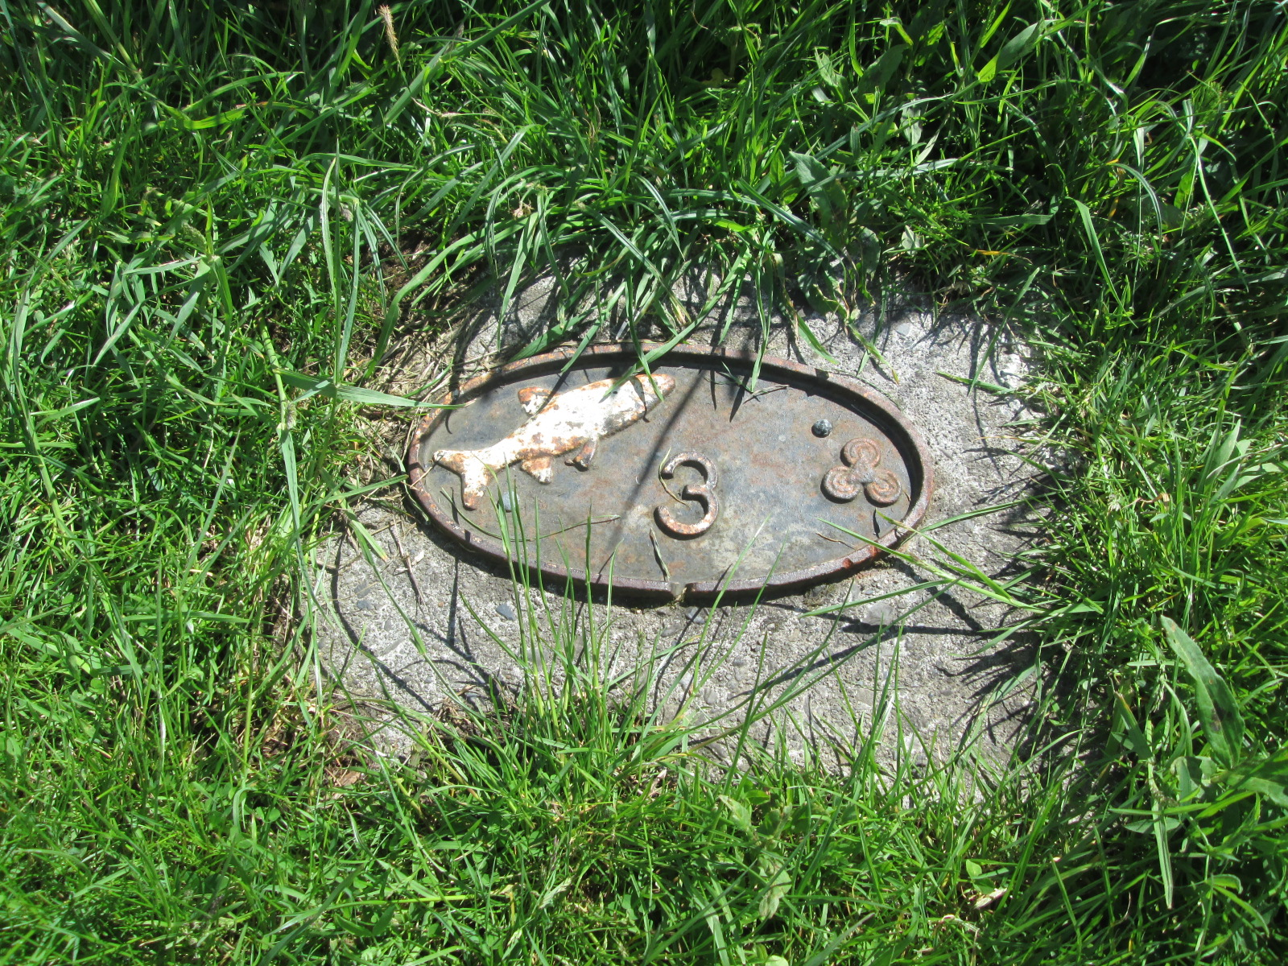

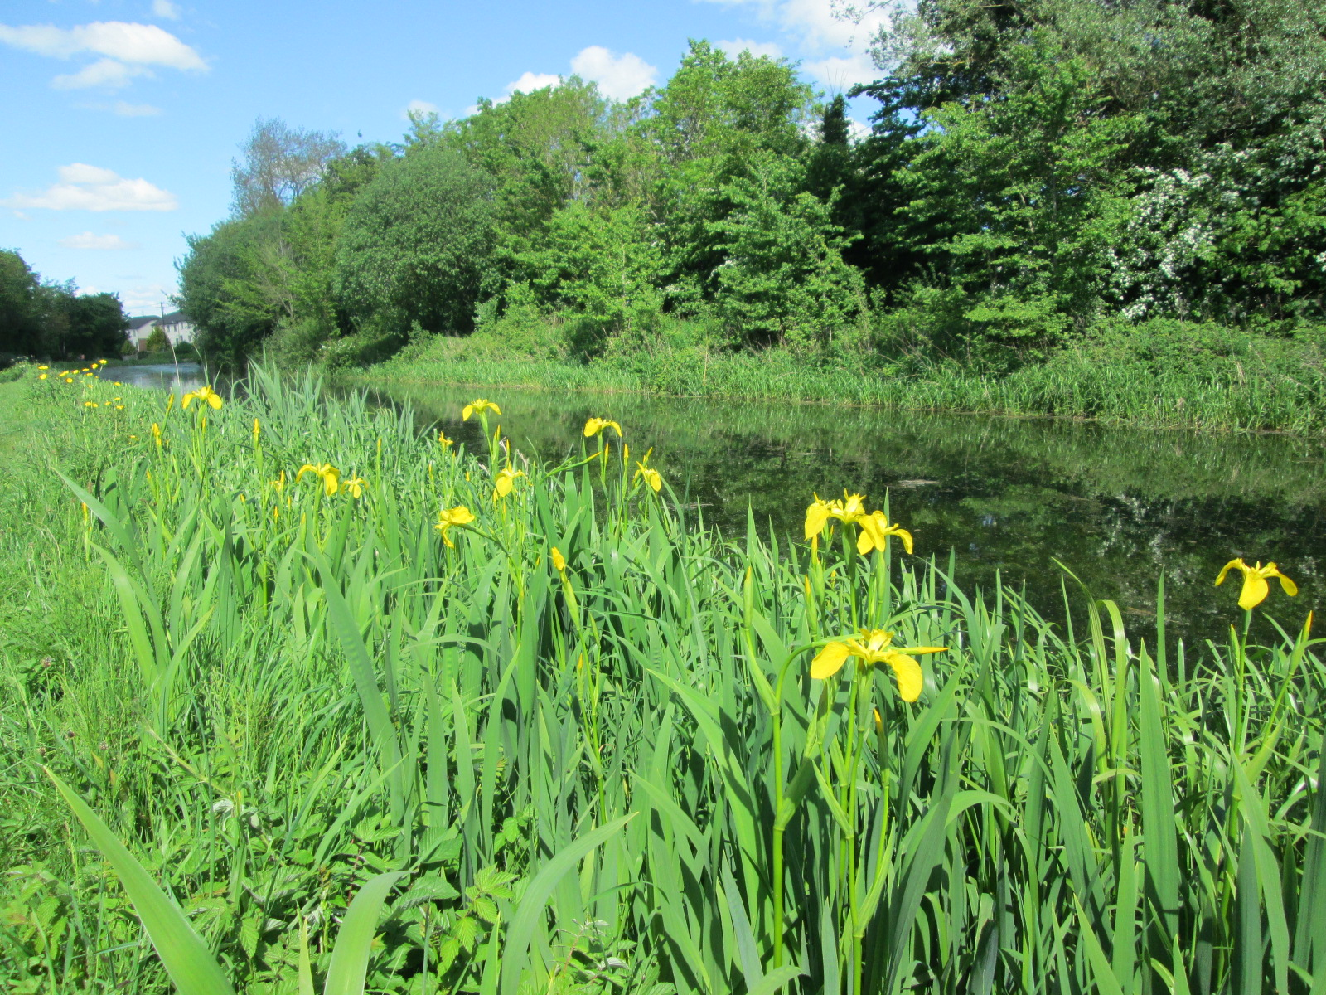

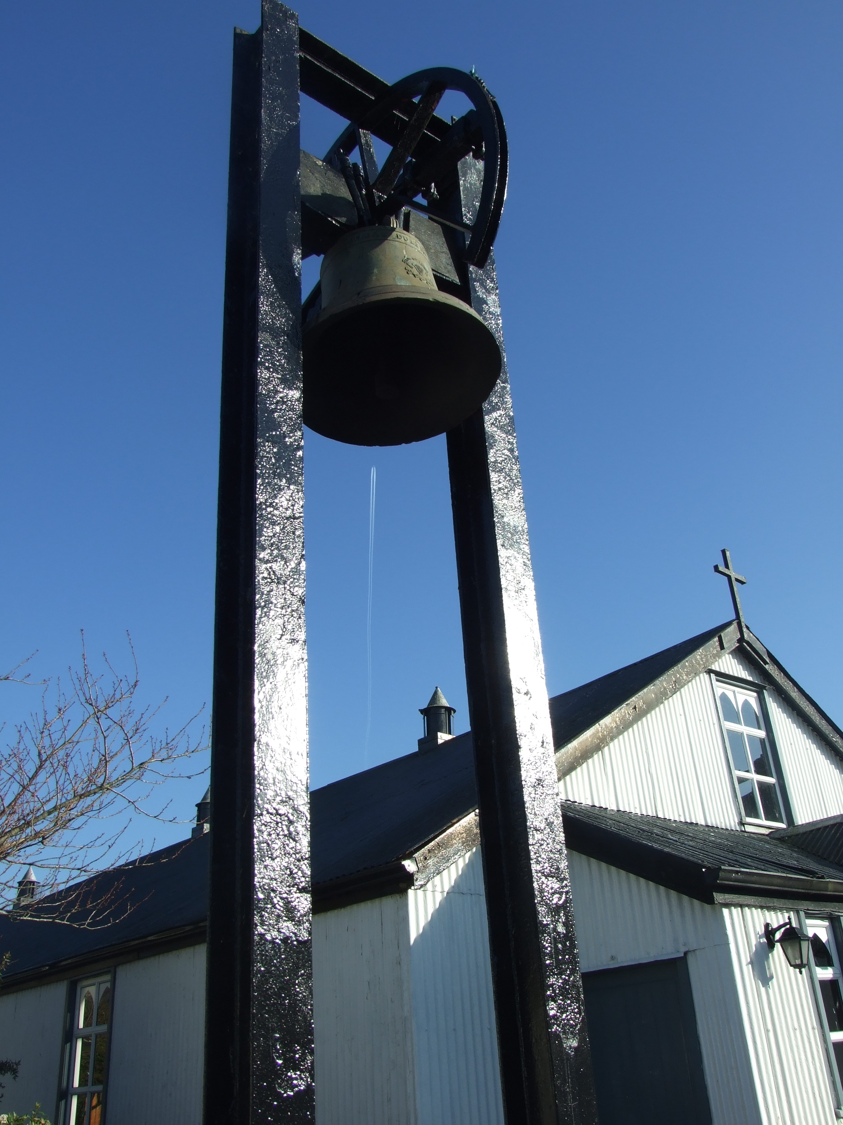

June 2015

Includes Ordnance Survey Ireland data
reproduced under OSi Licence number
2004/07 CCMA / Kildare County Council
Unauthorised reproduction infringes
Ordnance Survey Ireland and Government of Ireland
Copyright

© Ordnance Survey Ireland, 2015

Table of Contents

PART A
Introduction, Context and Development Strategy

- Introduction
- Sallins in Context
- Key Challenges
- SEA of Alternation Plan Scenarios
- Future Development Strategy

PART B
Policies and Objectives

- Introduction
- Compliance with Core Strategy of the Kildare County Development Plan 2011-2017
- Housing and the Core Strategy
- Enterprise, Industry and Economic Development
- Town Centre
- Design Briefs
- Movement and Transport
- Infrastructural Services
- Derelict and Vacant Sites
- Community and Recreational Facilities
- Architectural, Archaeological and Natural Heritage
- Green Infrastructure

PART C
Land Use Zoning

- Implementation

Tables
Table 1 Sallins Population and Rate of Change 1991-2011
Table 2 Permanent Private Households by year built
Table 3 Sallins Housing Unit Target 2015-2021
Table 4 Quantum of Land Required to Meet the Unit Target
Table 5 Quantum of New Residential Land (Zoned C) within the Plan
Table 6 Protected Structures in Sallins (extract from County RPS)
Table 7 Record of Monuments and Places
Table 8 Trees to be Protected
Table 9 Land Use Objectives
Table 10 Zoning Matrix

Figures

Figure 1 Population Growth in Sallins 1991-2011
Figure 2 Urban Footprint of Sallins
Figure 3 Preferred Scenario for the Development of Sallins
Figure 4 Sallins to Dublin by Canal
Figure 5 Urban Design/Landscape Architectural Framework Plan Boundary
Figure 6 Sallins in 1837
Figure 7 Location of Sallins Bypass

Maps

Map1 Land Use Zoning Objectives
Map 2 Movement Objectives
Map 3 Strategic Flood Risk Assessment
Map 4 Built Heritage
Map 5 Natural and Archaeological Heritage
Map 6 Green Infrastructure

